**EXP 11: CHANGE HARDWARE COMPATIBILITY OF A VM (EITHER BY CLONE/CREATE NEW ONE) WHICH IS ALREADY CREATED AND CONFIGURED.**

**DATE:1.10.2025**

**AIM:**

To Change Hardware compatibility of a VM (Either by clone/create new one) which is

already created and configured.

**PROCEDURE:**

STEP 1:GOTO VM WARE WORKSTATION.

STEP2: RIGHT CLICK THE VM AND GOTO THE SETTINGS.

STEP 3: ADD HARDWARE WIZARD AND SELECT SCSI AND CLICK NEXT.

STEP 4: CREATE NEW VIRTUAL DISK.

STEP 5: SELCT THE DISK SIZE AS 2.0. AND SELCT SPLIT VIRTUAL DISK INTO MULTIFILES.

STEP 6: GIVE NAME AND CLICK THE FINISH.

**IMPLEMENTATION:**

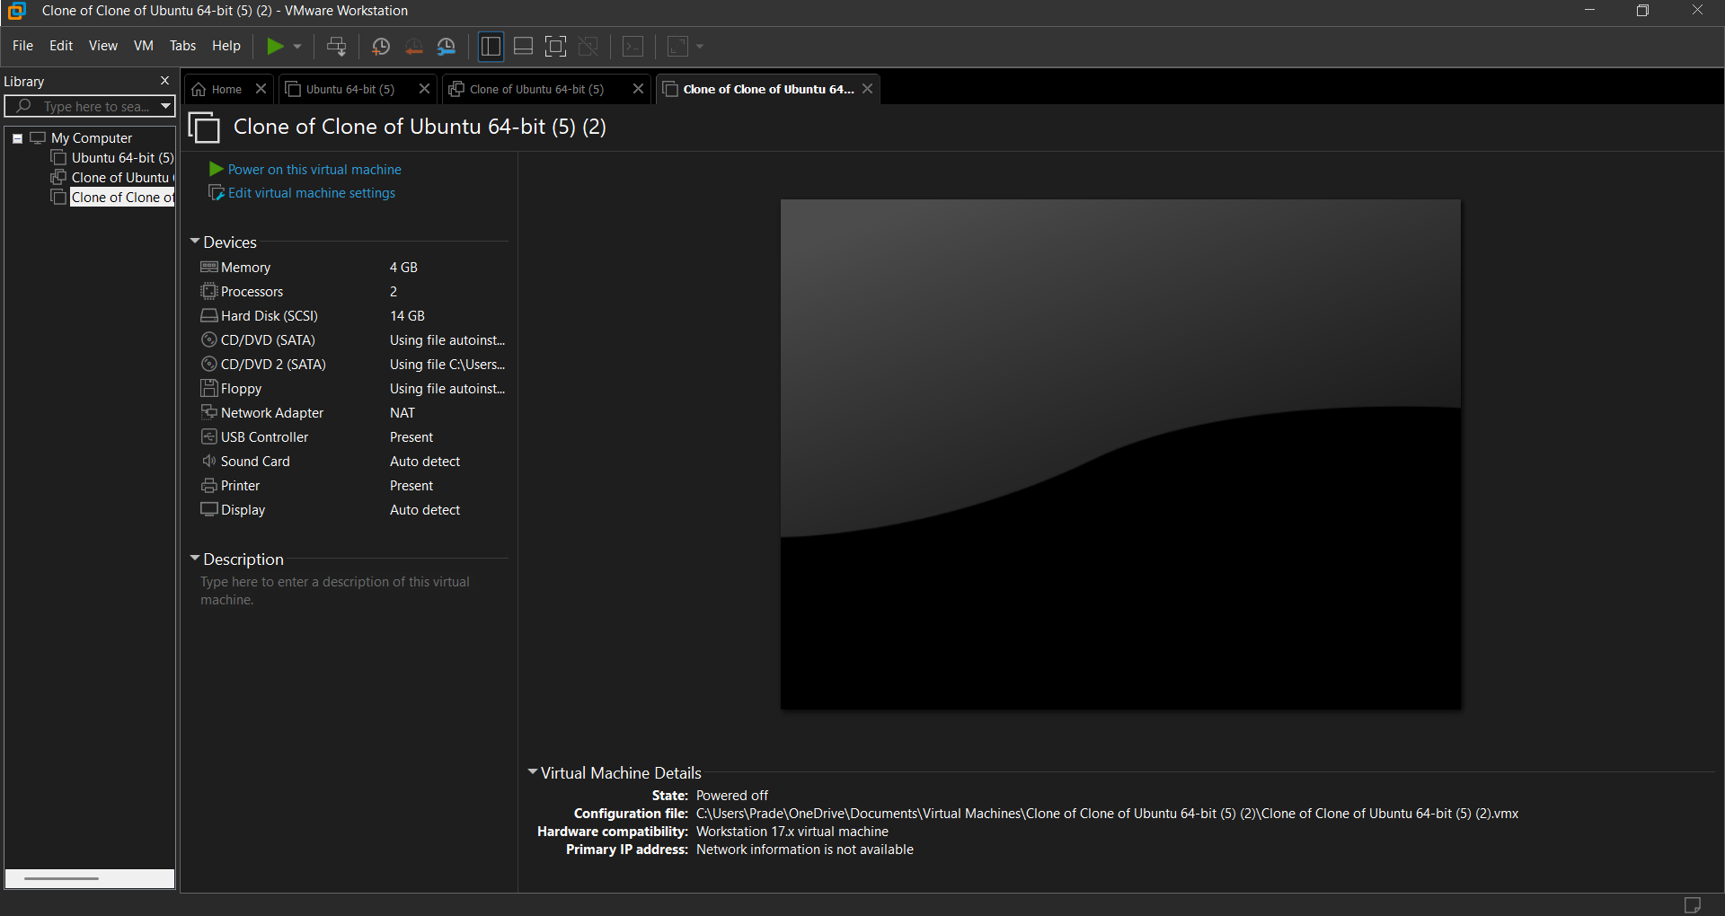

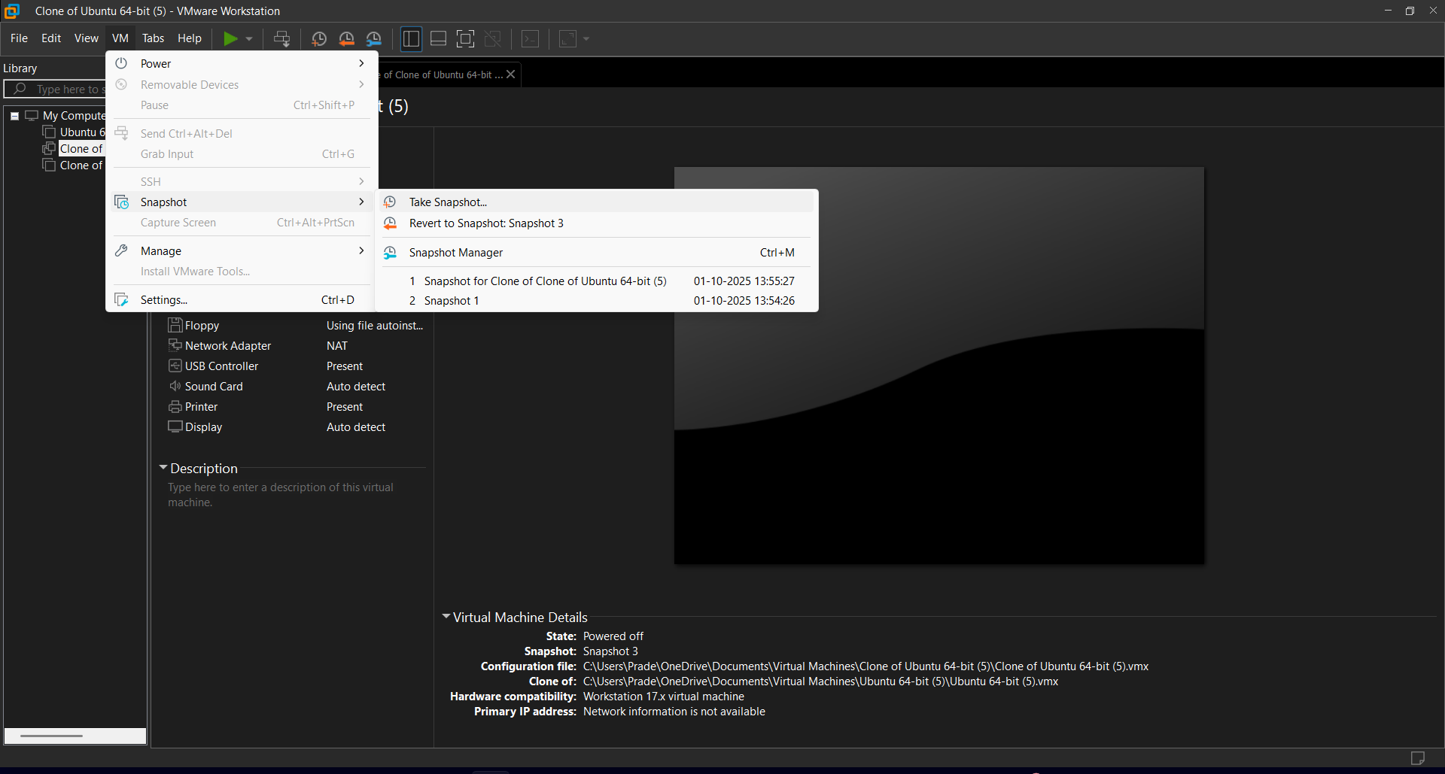

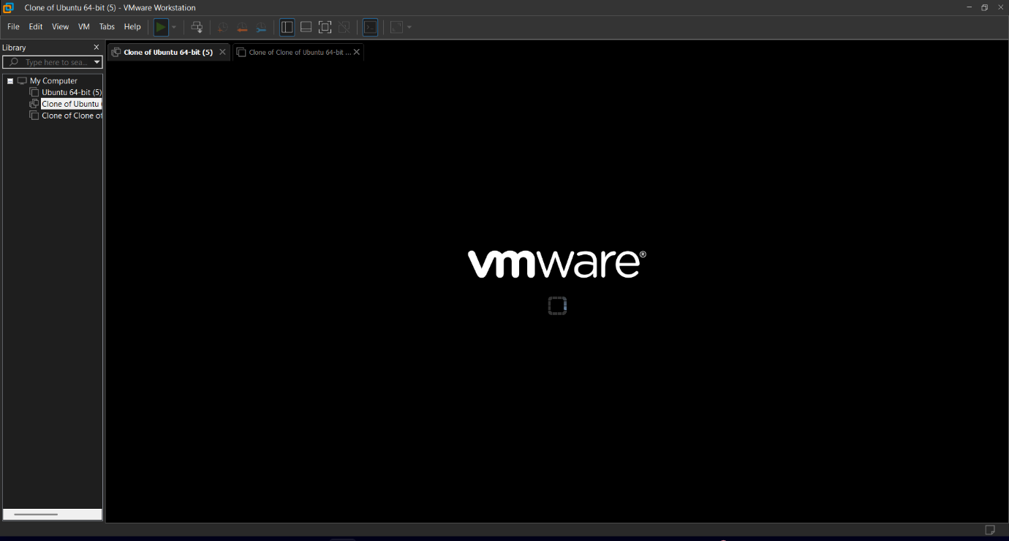

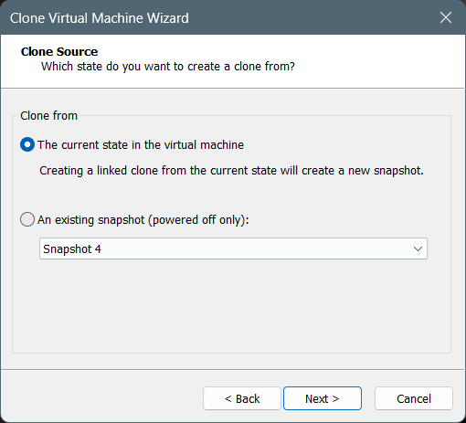

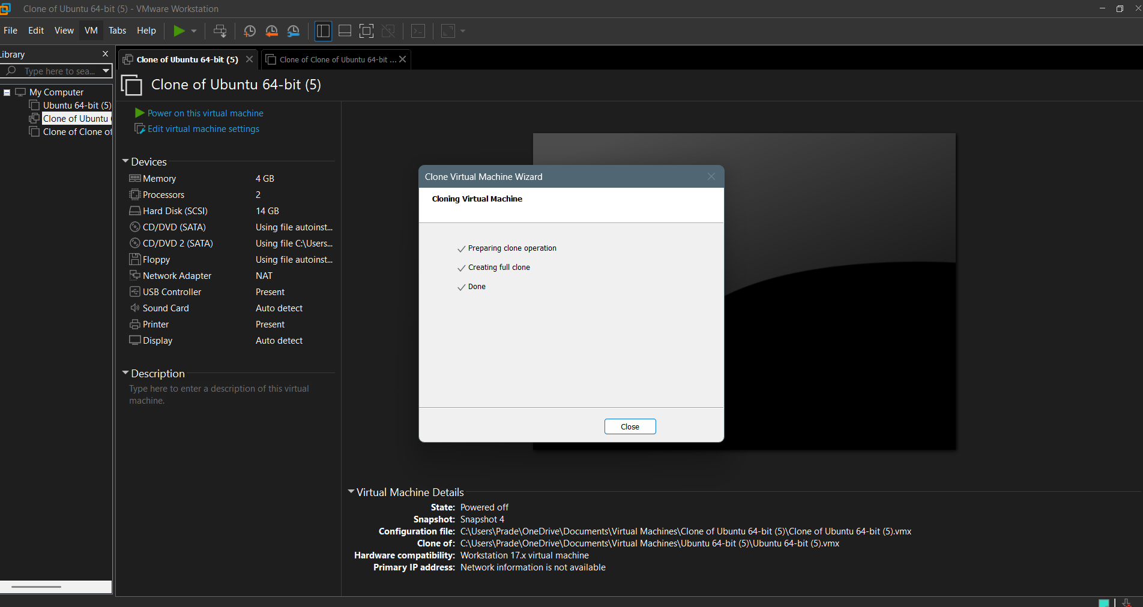

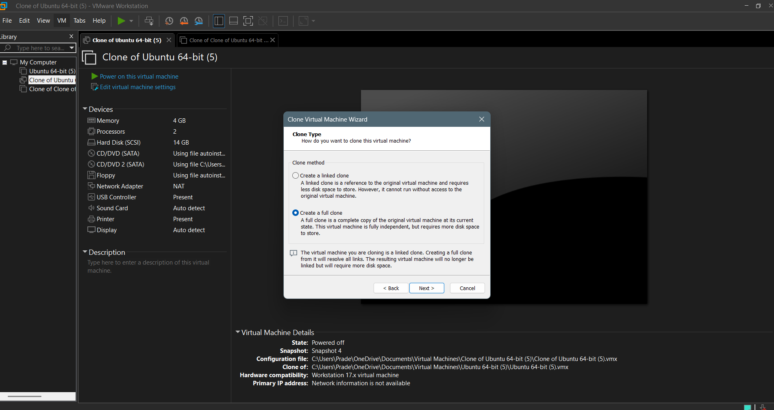

**RESULT:**

Hardware compatibility of a VM (Either by clone/create new one) which is

already created and configured has been changed.